Failed to open a session for the virtual machine **Ubuntu 18.04**.

The virtual machine **'Ubuntu 18.04'** has terminated unexpectedly during startup with exit code 1 (0x1). More details may be available in **'C:\Users\klieb\VirtualBox VMs\Ubuntu 18.04\Logs\VBoxHardening.log'**.

|  |  |
| --- | --- |
| Result Code: | E_FAIL (0x80004005) |
| Component: | MachineWrap |
| Interface: | IMachine {5047460a-265d-4538-b23e-ddba5fb84976} |

In general this error can only happen if there is a leftover from an old vboxdrv.sys driver of an older VirtualBox installation. This could be a bug in the VirtualBox installer or in the user environment. The general procedure to fix such problems is to unstall VirtualBox (your VMs will NOT vanish), then reboot, then re-install VirtualBox.

Before you re-install VirtualBox you should double-check if there are no old vboxdrv.sys drivers active, perhaps from an ancient VirtualBox installation. If you find such a driver, remove it and reboot the host again.

driverquery

should list all active drivers. If VirtualBox is not installed but the list contains VBoxDrv then make sure to remove any vboxdrv.sys instance you find on your system. Also make sure that VBoxNetAdp / VBoxNetFlt / VBoxNetLwf are not installed either.

Finally re-install VirtualBox.

Location of VM

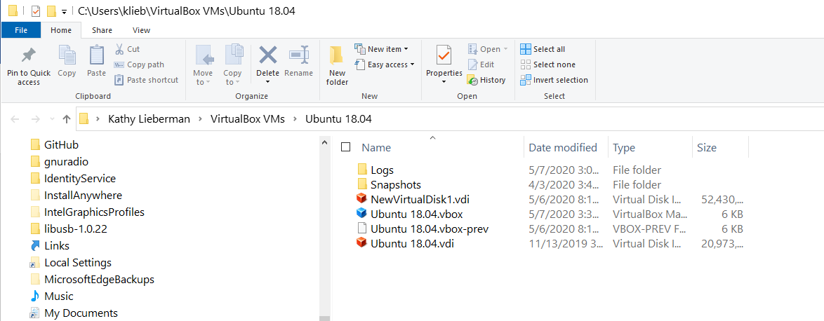

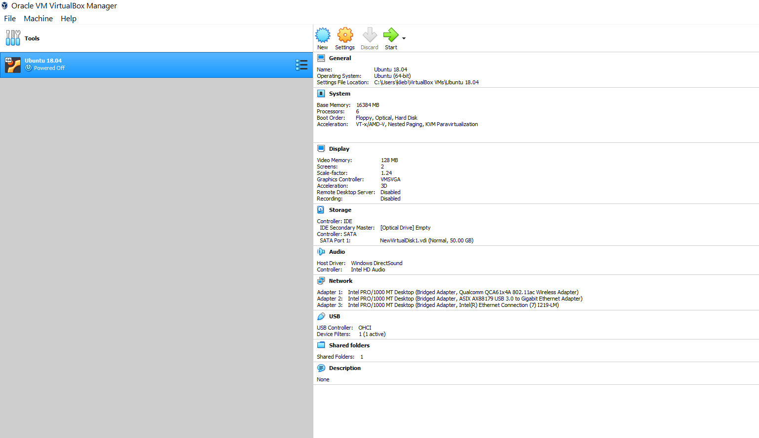

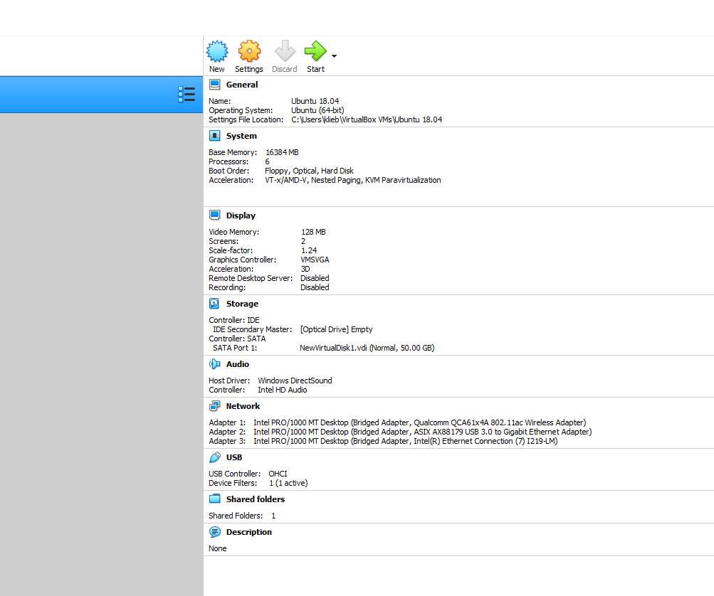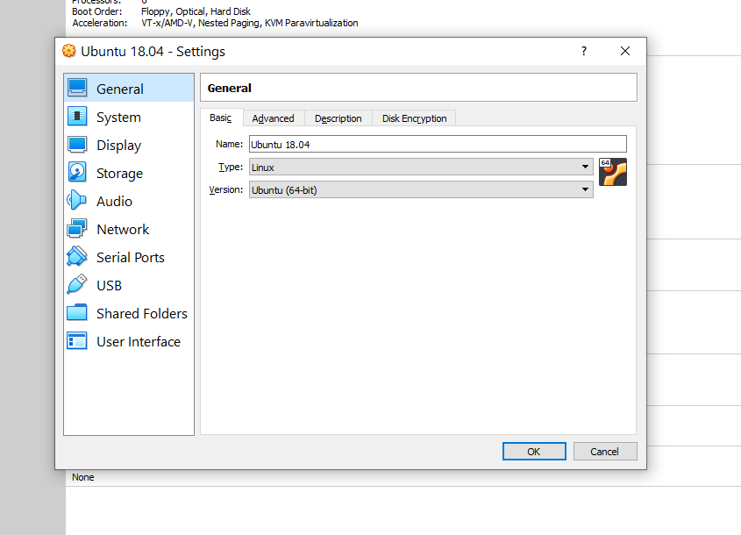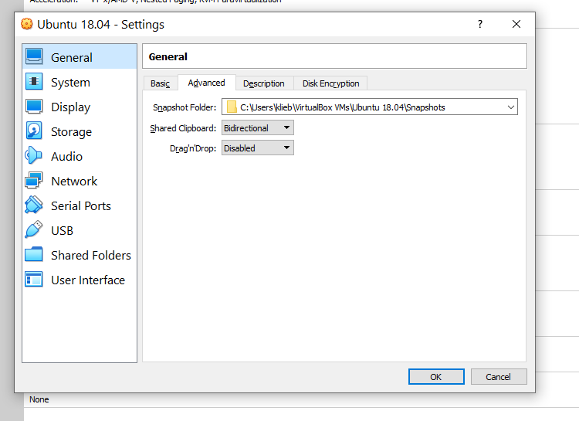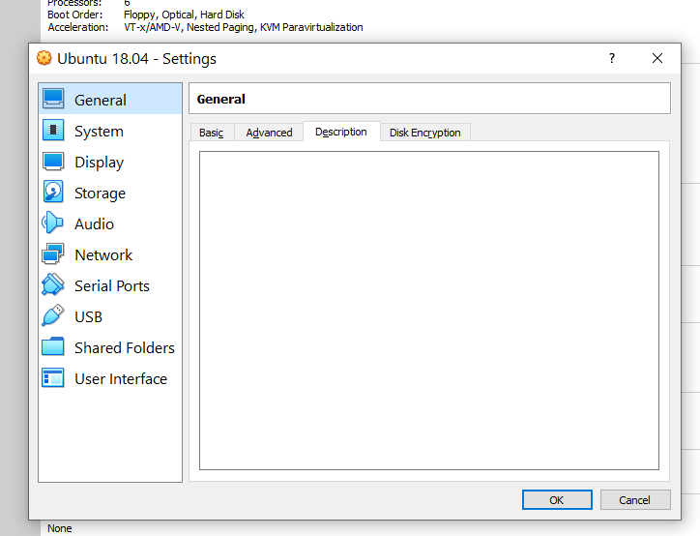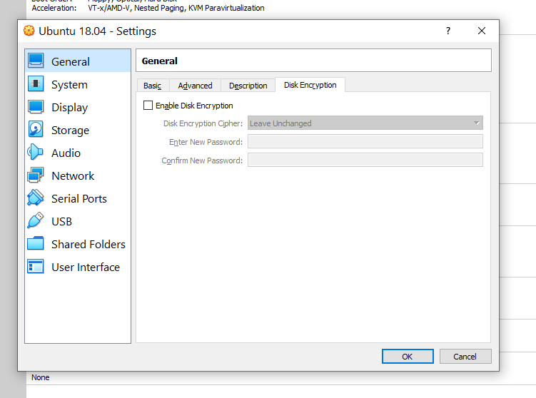

System

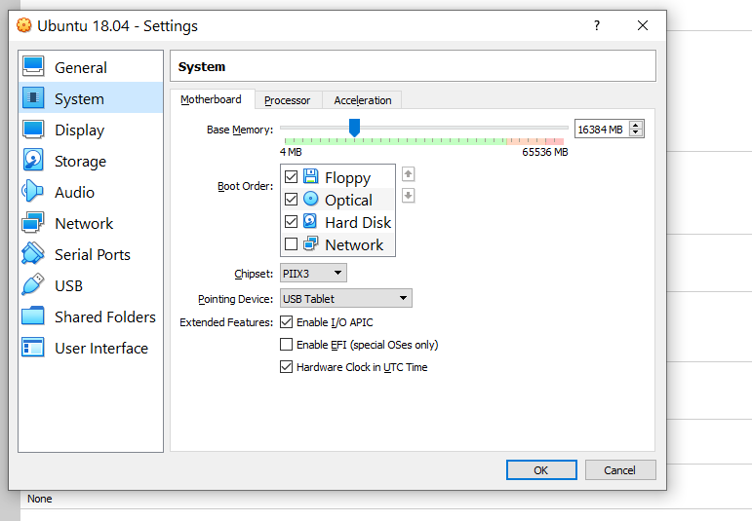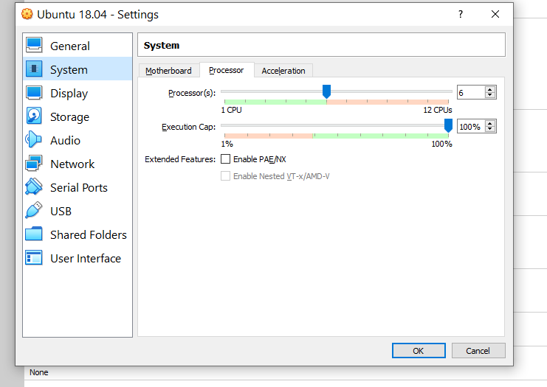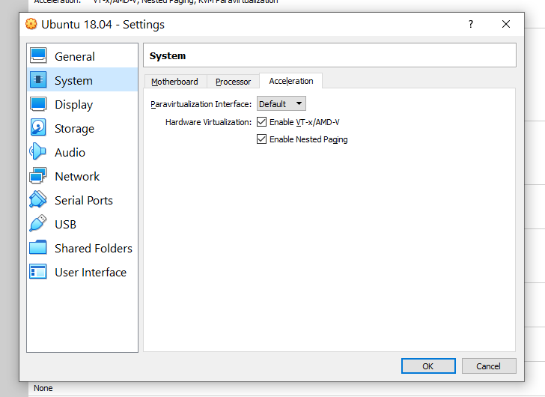

Display

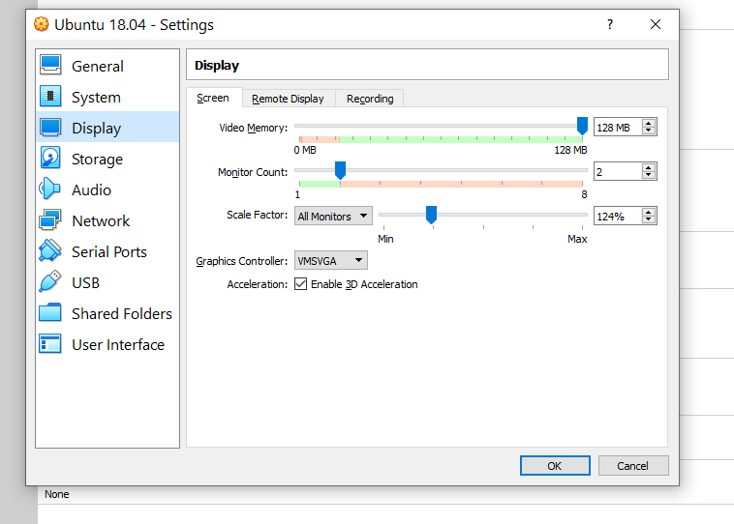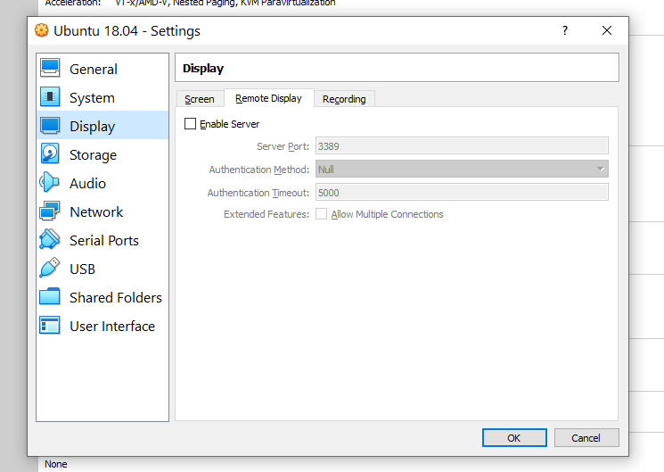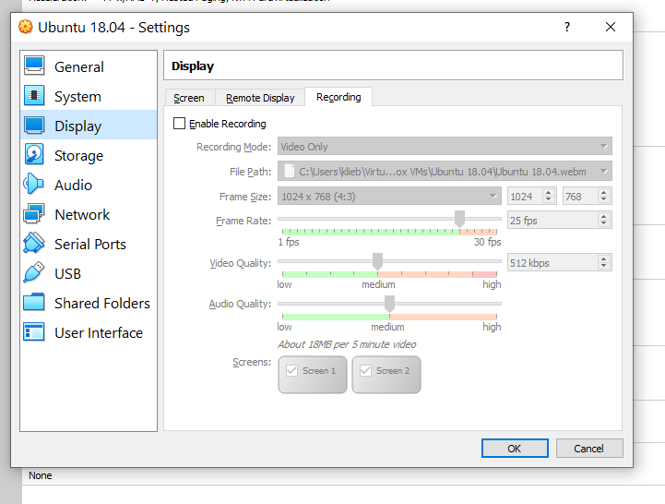

Storage

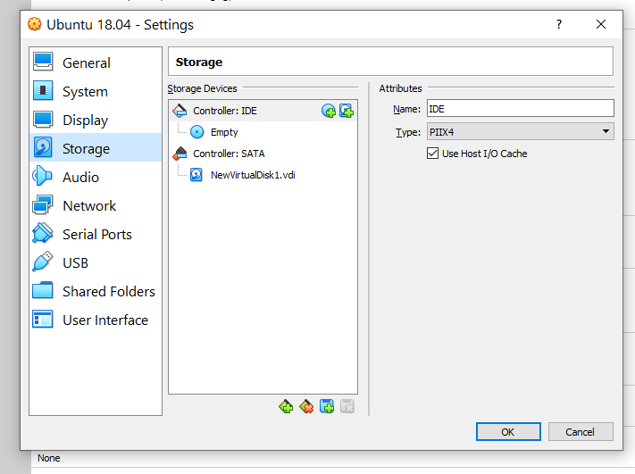

Audio

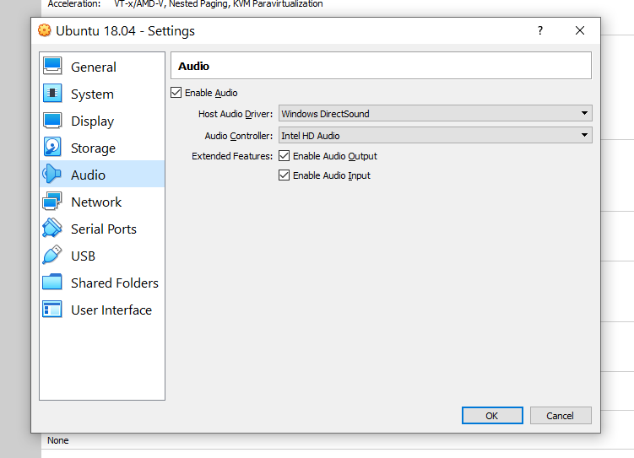

Network

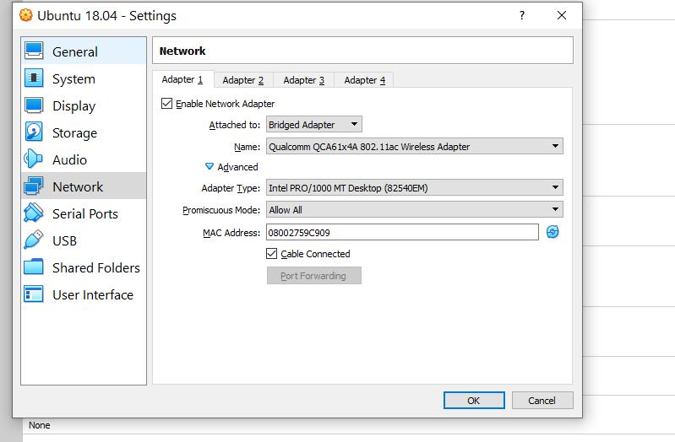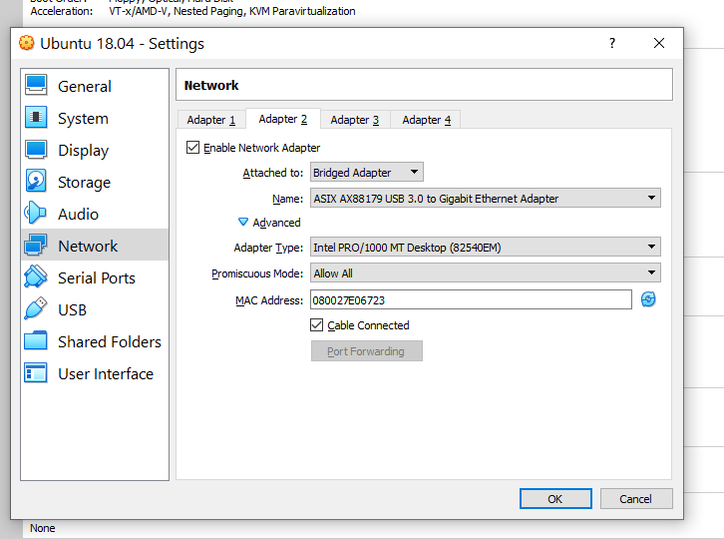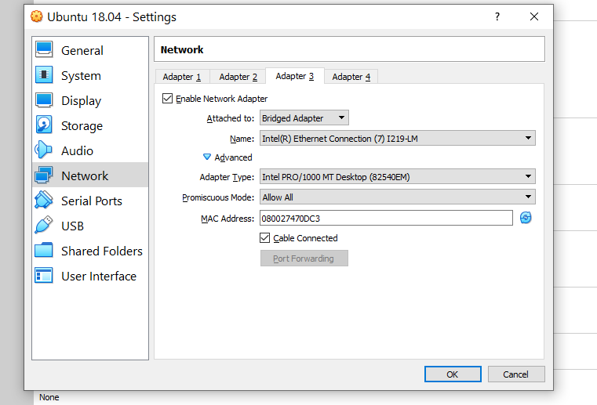

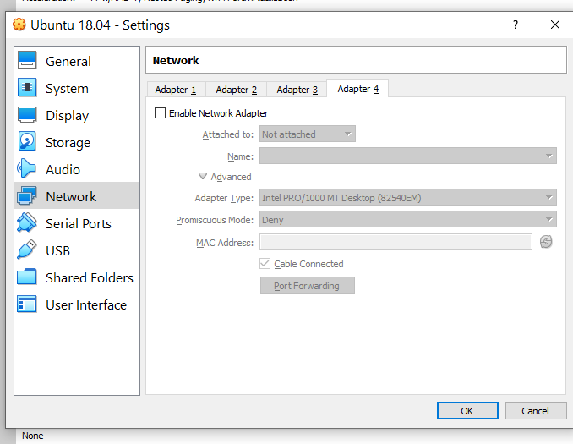

Serial Ports

(all the same—Unassigned) for all 4 ports

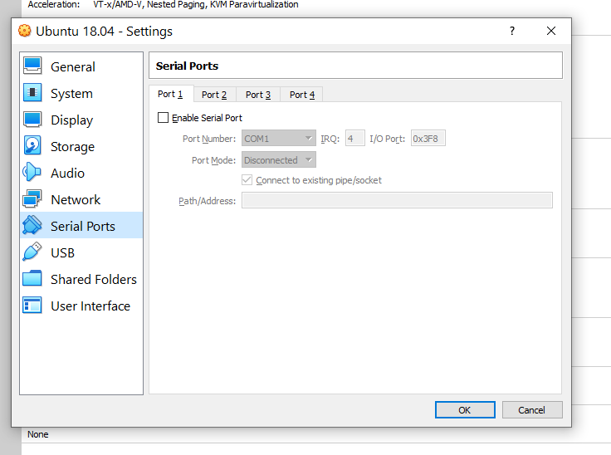

USB

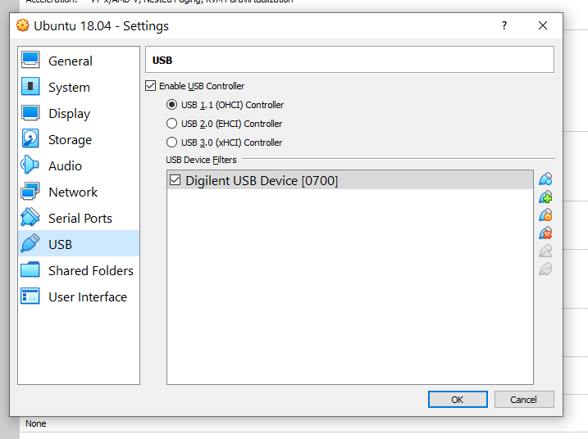

Shared Folders

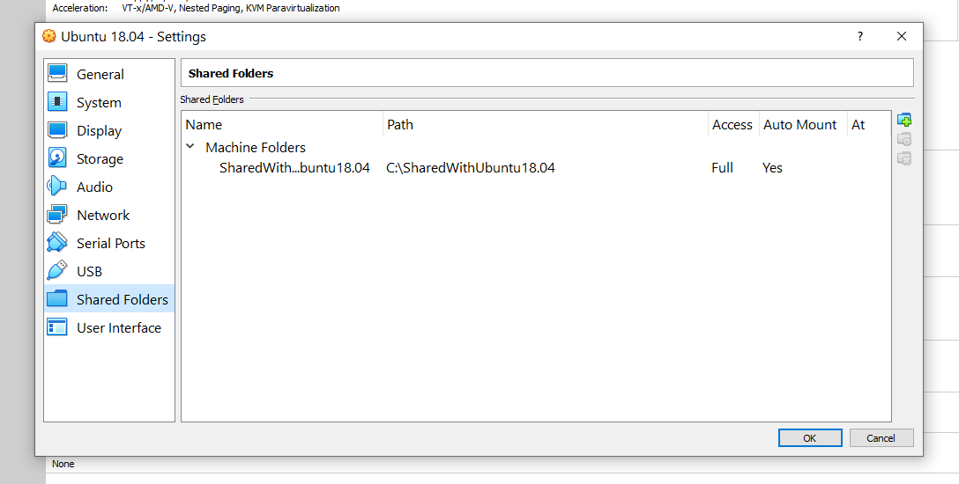

User Interface – Nothing here

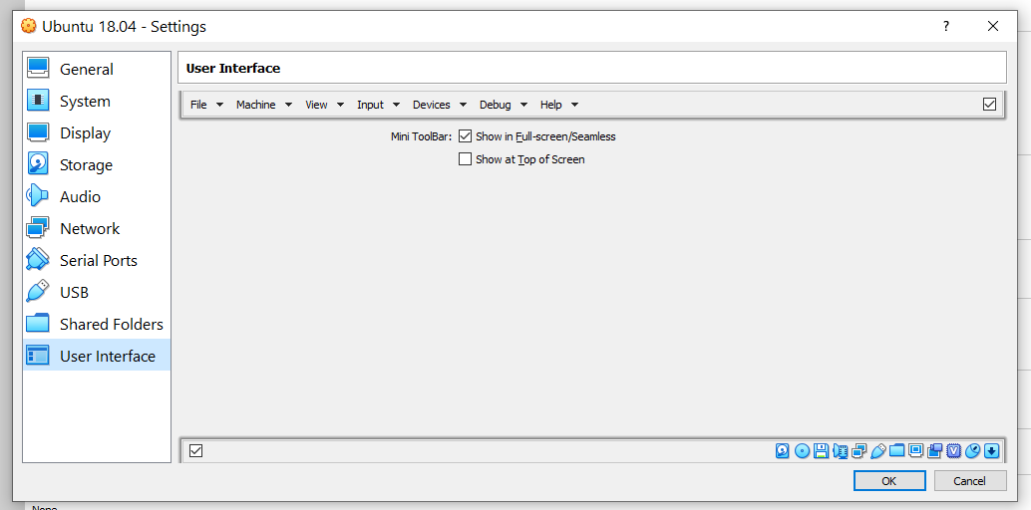

I uninstalled VBox 6.0.0, Rebooted, then reinstalled VBox 6.0.20 and when I open Vbox, it had my Ubuntu 18.04 already there and the same configuration as shown above.